2020 November Class Project

National University of Computer & Emerging Sciences FAST

Department of Computer Science

Course Number CS118
Course Title Programming Fundamentals SE&DS

Title of Course Work Class Project (Fire-DP)

Time/ Duration Allowed 3 Weeks

Instructions to Candidates:

Total Marks: 10% (6+4)
Part-I
Your programming code must include the following contents. Now advance topics and other graphic design methods are allowed to use.
Nested loops
Functions
Functions with default parameters
Arrays
Use of Static and Unitary etc.
Pointers (Bonus)
Part-II
Describe Problem Abstract (One paragraph)
Live Demo & Q&A
______________________________________________________________________________
For this assignment/ project you will be supplied with:

Fireworks Drawings with Programming (Fire-DP)

Assessment

This project emphasizes on problem solving with team work efforts. Only core programming with given contents are allowed to use. Fancy and colourful appearances are not necessary to adopt. Do not use fractal.

CASE BRIEF

Introduction

There are various shapes of fireworks are available with different types such as fish, palm etc. One different shape/ type is given to each group. You need to draw and manage programming as you have done using asterisks (*) for making triangle, square boxes and pyramids (in class/ lab) without hard coding (Figure-4). You can use two dimensional array to resolve issues of coordinates as shown in figure 2. Rough prototypes are shown in figure-3.

Produce problem abstract followed by Implemtation.


Figure-1: Fireworks

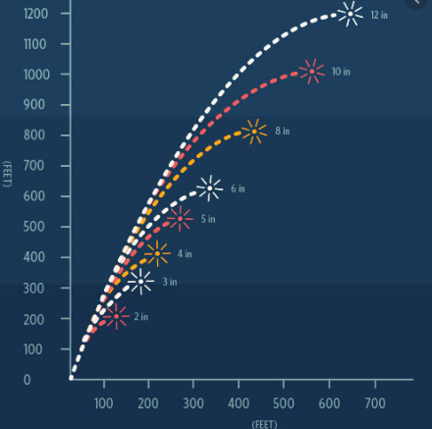
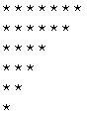
Figure-2: Curve graphs Figure-4: Basic drawing

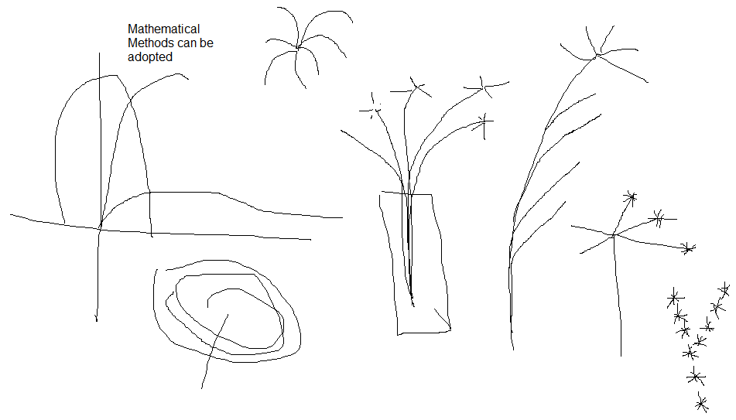
Figure-3: Rough prototypes of shapes

National University of Computer & Emerging Sciences

Computer Science Department

HOME WORK - ASSIGNMENT COVER SHEET

COURSE TITLE Programming Fundamentals COURSE CODE CS118

INSTRUCTOR EJAZ AHMED, MYRA KHALID, SHEHRYAR TYPE √ (Please tick)
Indiv. Group
ASSIGNMENT NO 1

ASSIGNMENT Class Project (Fire-DP)

HAND OUT DATE 26-NOV-2020 DUE DATE 15-NOV-2020

ESTIMATE TIME 30 Hours

ASSESSMENT CRITERIA (or attached) | % Mark
Instructions to Candidates:

Max of 3 or min of 2 students are allowed in a group

TO BE COMPLETED BY STUDENT (Who submitted) GROUP MEMBERS ID
ID Sec#

ID Sec#

ID Sec#

NAME

ID NO

Time Taken

DECLARATION: I/We declare that this Coursework is my/our group’s own work

SIGNATURES (All members)

GRADE/ MARK AWARDED COMMENTS

INSTRUCTOR’S SIGNATURE DATE

